15th April 2016

**YOKOHAMA Germany Exhibits at Tuning World Bodensee**

YOKOHAMA will be well represented at the forthcoming Tuning World Bodensee fair which takes place from 5th-8th May in Friedrichshafen. The Japanese Tyre manufacturer will be displaying an attractive and creative booth where it will offer visitors comprehensive product information on its wide range of tyres.

The booth will also benefit from a real eye catcher with exhibits such as a very finely tuned BRABUS Mercedes GLE 63 SUV as well as a spectacular Volvo 142 from 1969. YOKOHAMA’s customer Blepp restored the vintage car which is now proudly cladding YOKOHAMA’s ADVAN NEOVA ADO8R High Performance tyres.

Since the first edition of the Tuning World Bodensee, YOKOHAMA has been present at this International prestigious and popular Event for Car Tuning, Lifestyle and Club Scene.

In addition to these superb cars, visitors to the YOKOHAMA booth can also look forward a great social media photo session at booth 200 in Hall B1 on various activities around the theme of football. The outdoor area also offers the traditional YOKOHAMA off-road course.

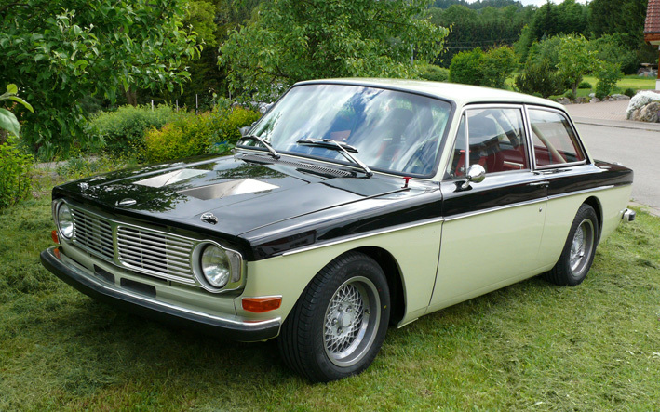

*Volvo 142 from 1969*

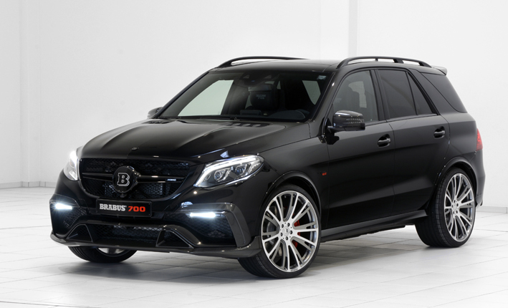

*BRABUS Mercedes GLE 63 SUV*